Task 1 — Role-Based Access Control
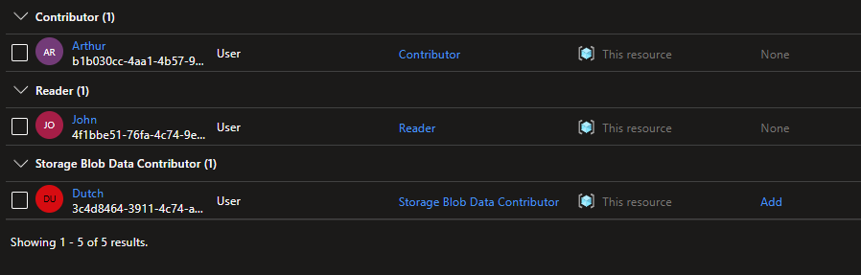
Assigning a role at the subscription level grants the user permissions across the entire subscription, while assigning it at the resource group level restricts access to only the resources within that specific resource group.
In this case, limiting user-ops (Arthur) to the resource group scope ensures he can only manage resources inside that group. This prevents him from making changes to other resource groups or resources outside his designated area, thereby properly enforcing the principle of least privilege.

Task 2 — Network Security Group
Direction | Port / Protocol | Source / Dest | Action | Business Justification
Inbound | 3389 | Specific IP | Allow | Remote management of VM
Inbound | 80 ,443 | Any | Allow | Web application access
Inbound | Any | Any | Deny | Least-privilege default — block all other inbound
Outbound | 443 | Internet | Deny | Prevent data exfiltration from VMs
Inbound:
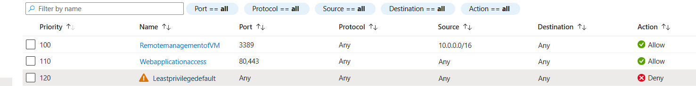
Outbound:
Task 3:

